**ICS3Ua Final Project Report On**

**“Video Game Store Website”**



**SUBMITTED TO: AMBERSON COLLEGE**

In partial fulfillment of the requirements for the award of degree

of

Secondary Education

| **Submitted by:** | **Submitted to:** |
| --- | --- |
| **Chong Zhuang** | **Ms. Namarta Vij** |
| **Sheng Chen** |
| **Yanbo Wang** |
| **Yun Ki Zhang** |

**DEPARTMENT OF MANAGEMENT**

**AMBERSON COLLEGE**

**(2025)**

**To whomsoever it may concern**

This is to certify that the project report entitled “Game Store Software Development” carried out by Chong Zhuang, Sheng Chen, Yanbo Wang, and Yunki Zhang have been accomplished under Mrs. Namarta Vij as duly registered students of Amberson High School. This project is being submitted by them in the partial fulfillment of the requirement for the final exam.

Their dissertation represents the original work.

**Declaration**

I, “Chong Zhuang*”,* hereby declare that the work presented herein is genuine work done originally by me and has not been published or submitted elsewhere for the requirement of a degree program. Any literature, data or works done by others and cited within this dissertation has been given due acknowledgement listed in the reference section.

**Chong Zhuang**

(Student’s Signature)

Date: ___________

**Declaration**

I, “Sheng Chen*”,* hereby declare that the work presented herein is genuine work done originally by me and has not been published or submitted elsewhere for the requirement of a degree program. Any literature, data or works done by others and cited within this dissertation has been given due acknowledgement listed in the reference section.

**Sheng Chen**

(Student’s Signature)

Date: ___________

**Declaration**

I, “Yanbo Wang*”,* hereby declare that the work presented herein is genuine work done originally by me and has not been published or submitted elsewhere for the requirement of a degree program. Any literature, data or works done by others and cited within this dissertation has been given due acknowledgement listed in the reference section.

**Yanbo Wang**

(Student’s Signature)

Date: ___________

**Declaration**

I, “Yun Ki Zhang*”,* hereby declare that the work presented herein is genuine work done originally by me and has not been published or submitted elsewhere for the requirement of a degree program. Any literature, data or works done by others and cited within this dissertation has been given due acknowledgement listed in the reference section.

**Yun Ki Zhang**

(Student’s Signature)

Date: ___________

**Abstract**

**The project built a gaming platform where players could browse, buy, and review games. There is a system for users that allows players to manage their game collections, share reviews, and interact with like-minded people. There is also an admin system that can add games to the store, delete reviews and other features. This project will focus on designing and implementing a video game store website using Java.**

**Table of Contents**

**Chapter-1 ........................................................................................................................ 1**

**Introduction of Java ...................................................................................................... 8 Chapter-2 ....................................................................................................................... 10 Introduction of Eclispe ................................................................................................. 10 Chapter-3 ....................................................................................................................... 11**

**Configuration ................................................................................................................ 11**

**Chapter-4 ....................................................................................................................... 19**

**Analysis .......................................................................................................................... 19**

**Conclusion ..................................................................................................................... 54**

**Chapter-5 ....................................................................................................................... 54 References ...................................................................................................................... 5**

**Chapter-1**

**Introduction：**

Java is a class-based, object-oriented programming language that is designed to have as few implementation dependencies as possible. It is intended to let application developers Write Once and Run Anywhere, meaning that compiled Java code can run on all platforms that support Java without the need for recompilation. **J**ava was developed by James Gosling at SunMicrosystems Inc. in May 1995 and later acquired by Oracle Corporation and is widely used for developing applications for desktop, web, and mobile devices.

Java is known for its simplicity, robustness, and security features, making it a popular choice for enterprise-level applications. Java applications are compiled to byte code that can run on any Java Virtual Machine.

Java is an object-oriented language that promotes the use of objects and classes. Organizing a program in a collection of objects is an object-oriented programming style, where each object represents an instance of a class.

The four main concepts of object-oriented programming are:

Abstraction

Encapsulation

Inheritance

Polymorphism

Java language is powerful which means reliable. It is developed in such a way that errors can be checked early on, that is why Java compiler can detect even errors that are not easily detected in other programming languages. The main features of Java that make it powerful are garbage collection, exception handling, and memory allocation.

Java supports multithreading which enables multiple parts of a program to be executed simultaneously. This feature is particularly useful for applications that require high performance like games and real-time simulations.

**Chapter-2**

**Introduction to Eclipse**

Eclipse is a widely respected open-source Integrated Development Environment (IDE) renowned for its versatility and robust feature set. While it excels in Java development, its extensive plugin ecosystem allows support for various programming languages such as C++, Python, PHP, and JavaScript, making it a preferred choice for diverse projects.

The IDE enhances the software development lifecycle by offering tools for coding, debugging, testing, and deployment. Its advanced code editor features syntax highlighting, auto-completion, and real-time error checking, boosting coding efficiency and early error detection.

Eclipse's sophisticated debugger enables line-by-line code execution, breakpoint setting, and runtime variable inspection, facilitating efficient issue resolution. Conditional breakpoints add further precision to the debugging process.

In project management, Eclipse provides structured organization of files, libraries, and dependencies, supporting various project types like Java, Maven, and Git repositories. Its extensible architecture allows functionality enhancement through plugins, such as EGit for Git integration and Maven for dependency management.

The IDE's customizable interface lets developers tailor views, perspectives, and toolbars to their preferences, ensuring an intuitive environment. Support for multiple workspaces allows seamless transitions between different project settings.

Eclipse's robust plugin ecosystem, accessible via the Eclipse Marketplace, extends its capabilities with tools for testing frameworks like JUnit, cloud platform integrations, and database management systems, ensuring adaptability to evolving development needs.

A strong global community contributes to continuous improvements, with extensive documentation and forums aiding both new and experienced users. Eclipse's performance and scalability make it suitable for both individual and enterprise-level projects, maintaining responsiveness even with large codebases and supporting collaborative development through shared repositories and remote debugging.

In summary, Eclipse is a comprehensive, adaptable, and community-supported IDE that caters to a wide range of development needs, making it an indispensable tool for developers worldwide.

**Chapter-3**

**Computer configuration**

**Chong**：

Detailed Information

Processor: Intel 13th Gen Core i7-1360P (12 cores)

Motherboard: HP 8878

Memory: Samsung 32GB DDR4 3200MHz (16GB + 16GB)

Graphics: Intel(R) Iris(R) Xe Graphics (128MB / HP)

Storage: SAMSUNG MZVL41T0HBLB-00BH2 (1024GB)

Audio: Realtek High Definition Audio

**Yanbo Wang：**Processor: 13th Gen Intel(R) Core(TM) i5-13500H 2.60 GHz

Onboard RAM: 32.0 GB (31.7 GB usable)

Device ID: B9A39C53-2E1F-4AF3-9D40-647A806E9FF3

Product ID: 00342-30974-00436-AAOEM

System Type: 64-bit operating system, x64-based processor

Pen and Touch: No pen or touch input available for this display

**Sheng chen:**

Name: MacBook Pro

Chipset: Apple M4

Memory: 16GB

Storage: 512GB

**Yun Ki Zhang:**

Processor: Intel(R) Core(TM) i7-8650U CPU @ 1.90GHz 2.11 GHz

Onboard RAM: 16.0 GB

System Type: 64-bit operating system, x64-based processor

**Chapter-4**

**Part 1:**

Create a Game class and use ArrayLists to store games. Implement functionality for adding, searching, displaying, and purchasing games.

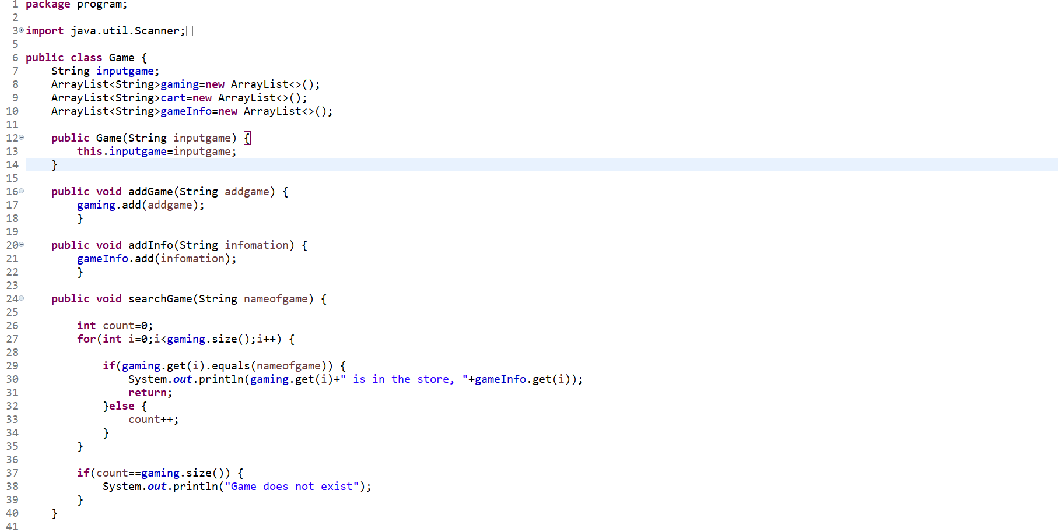

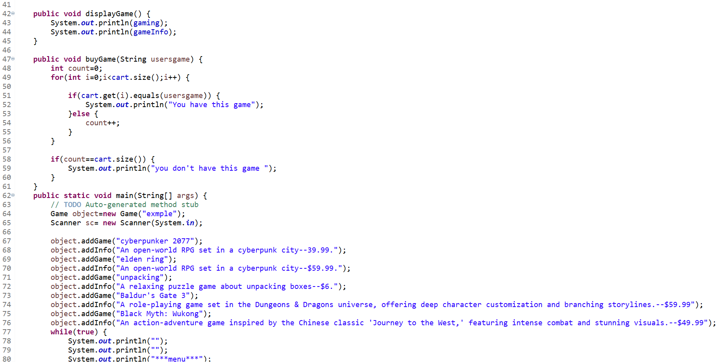

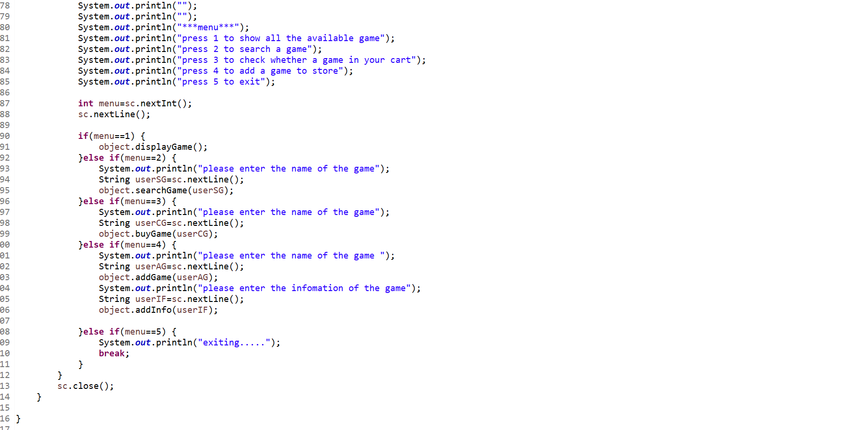

**Part 2:**

Design a User class to support user registration and login. Use ArrayList to store a user's game collection.

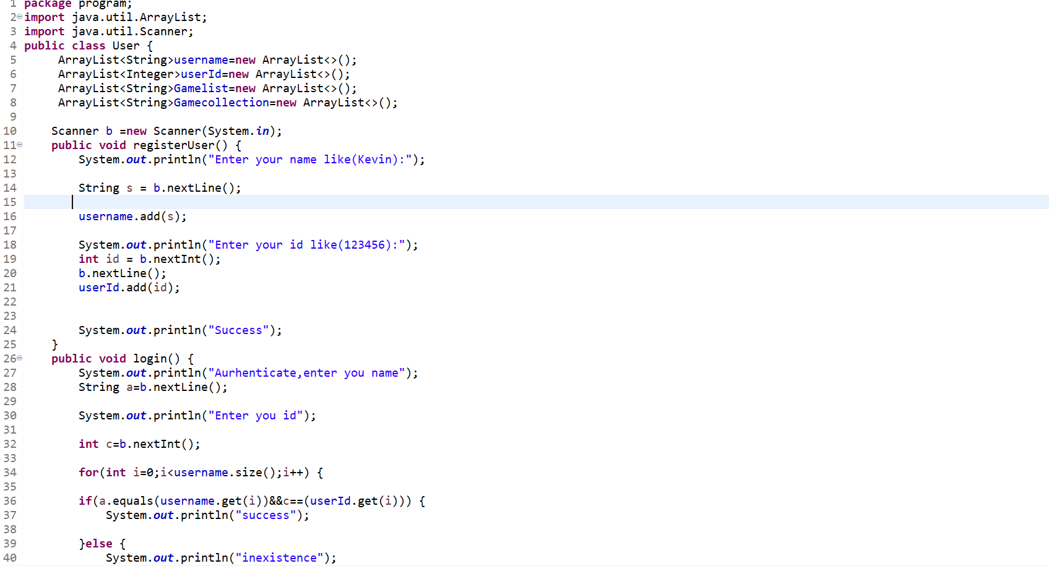

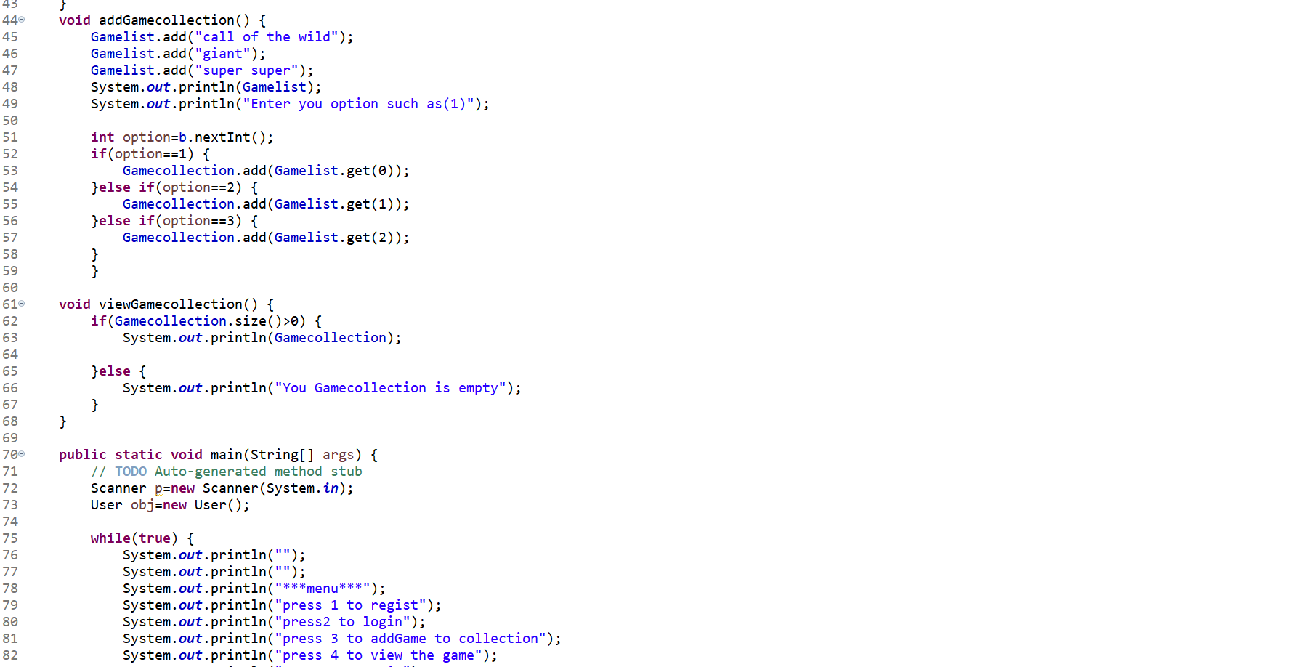

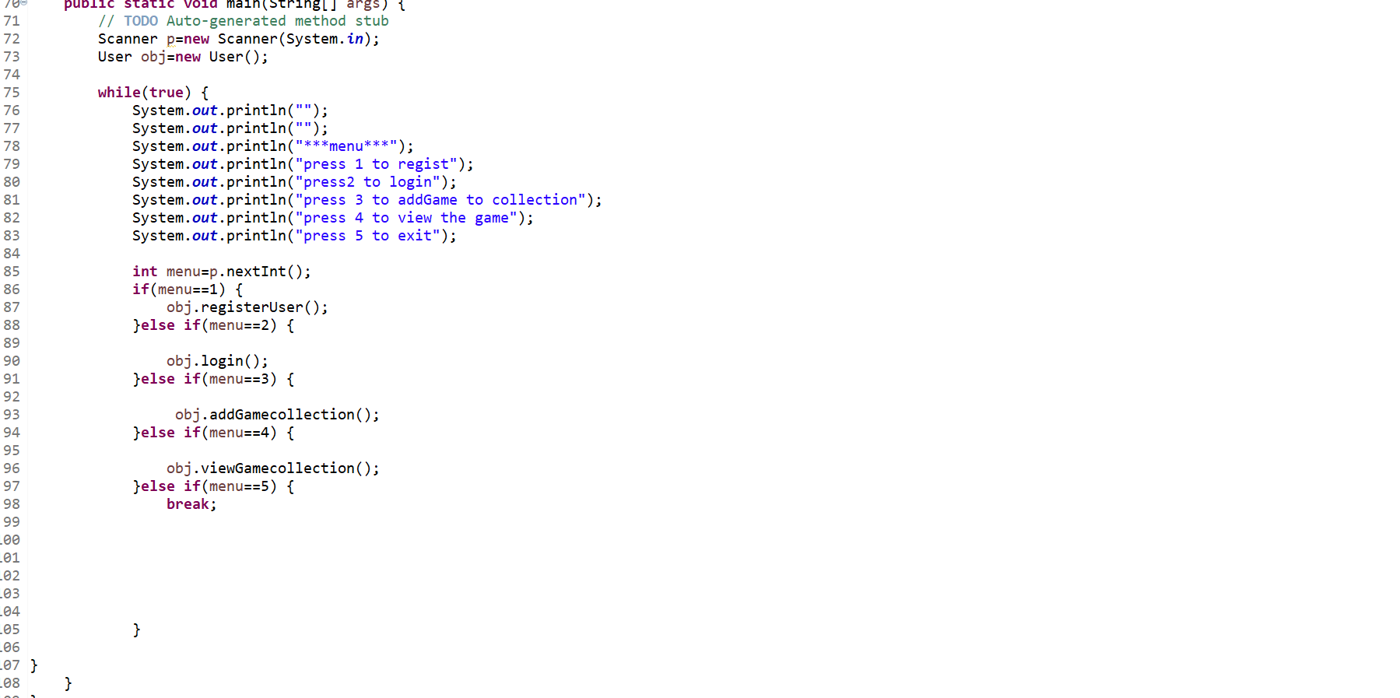

**Part 3:**

Develop a Review class to allow users to rate games and write reviews.

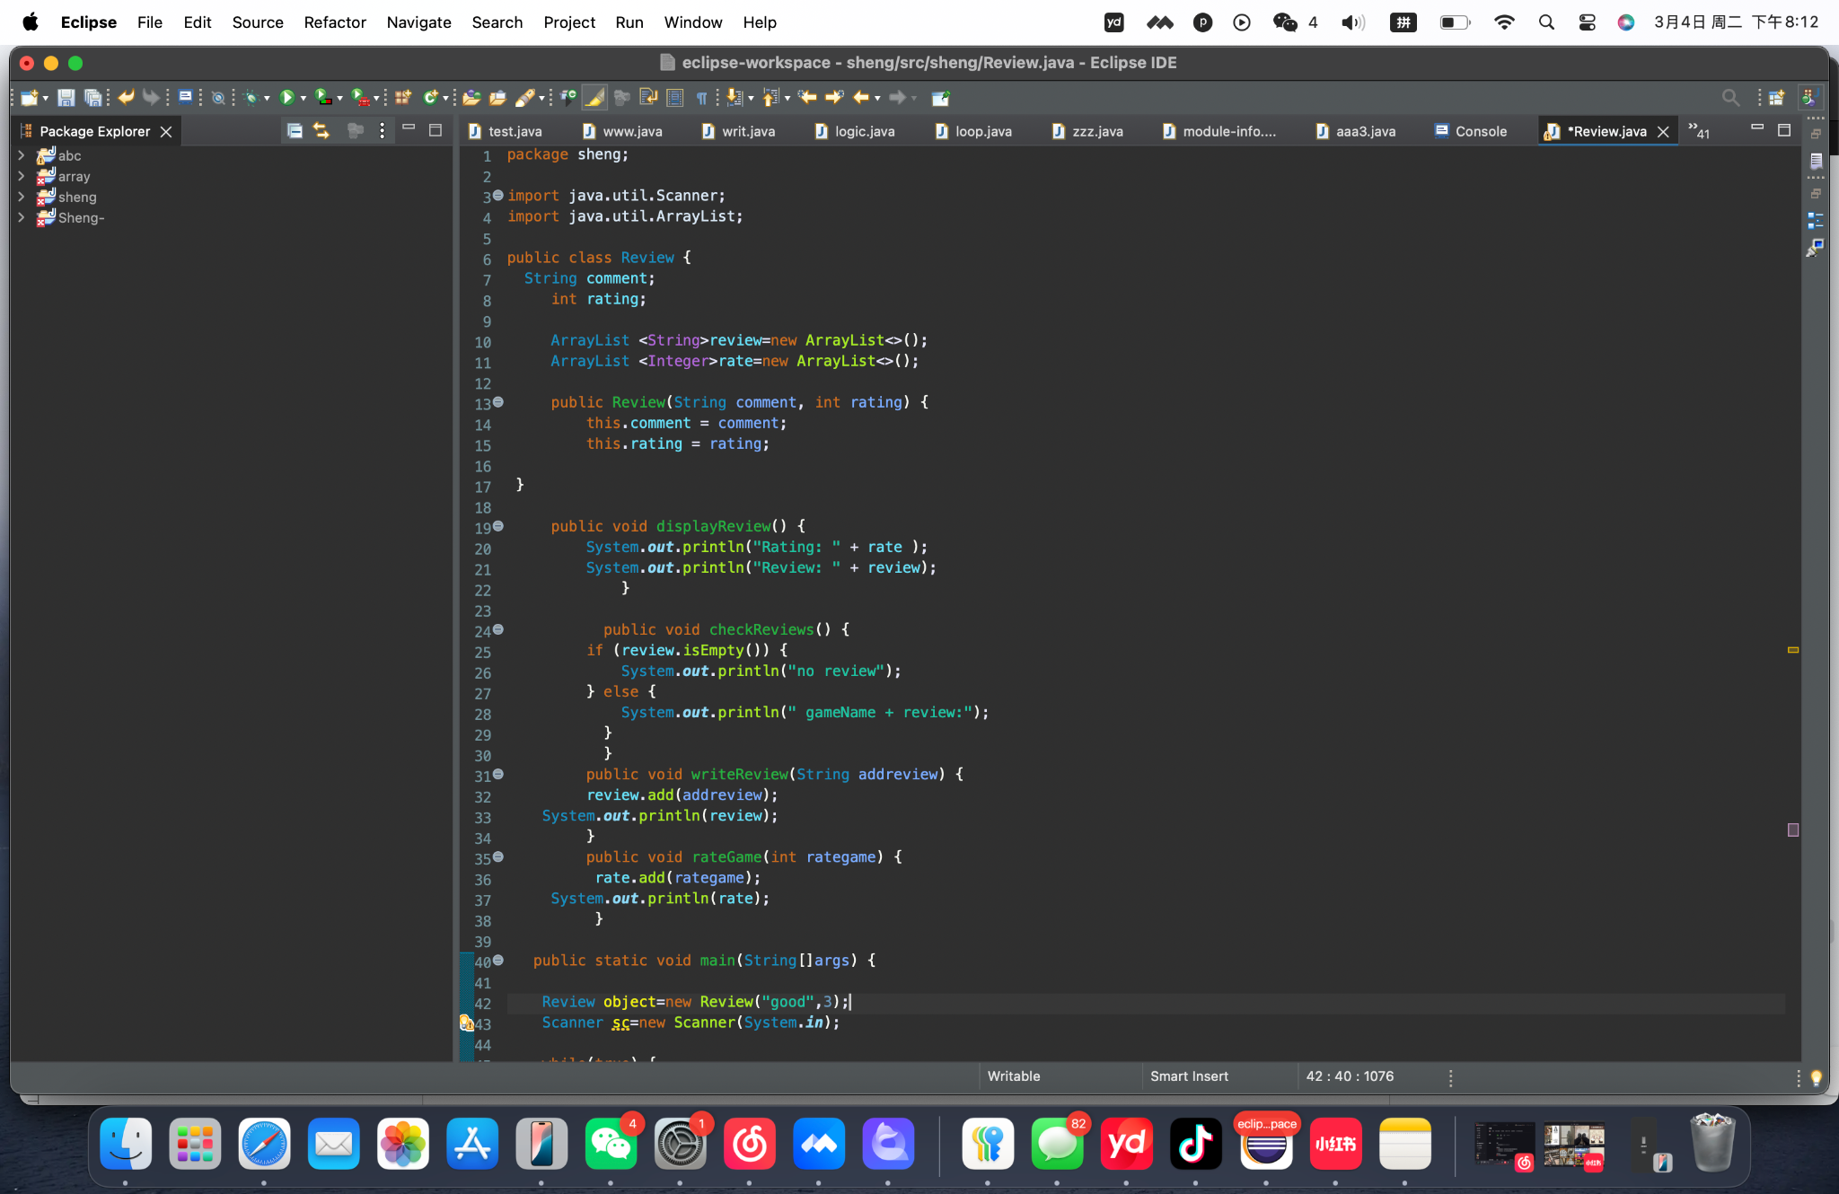

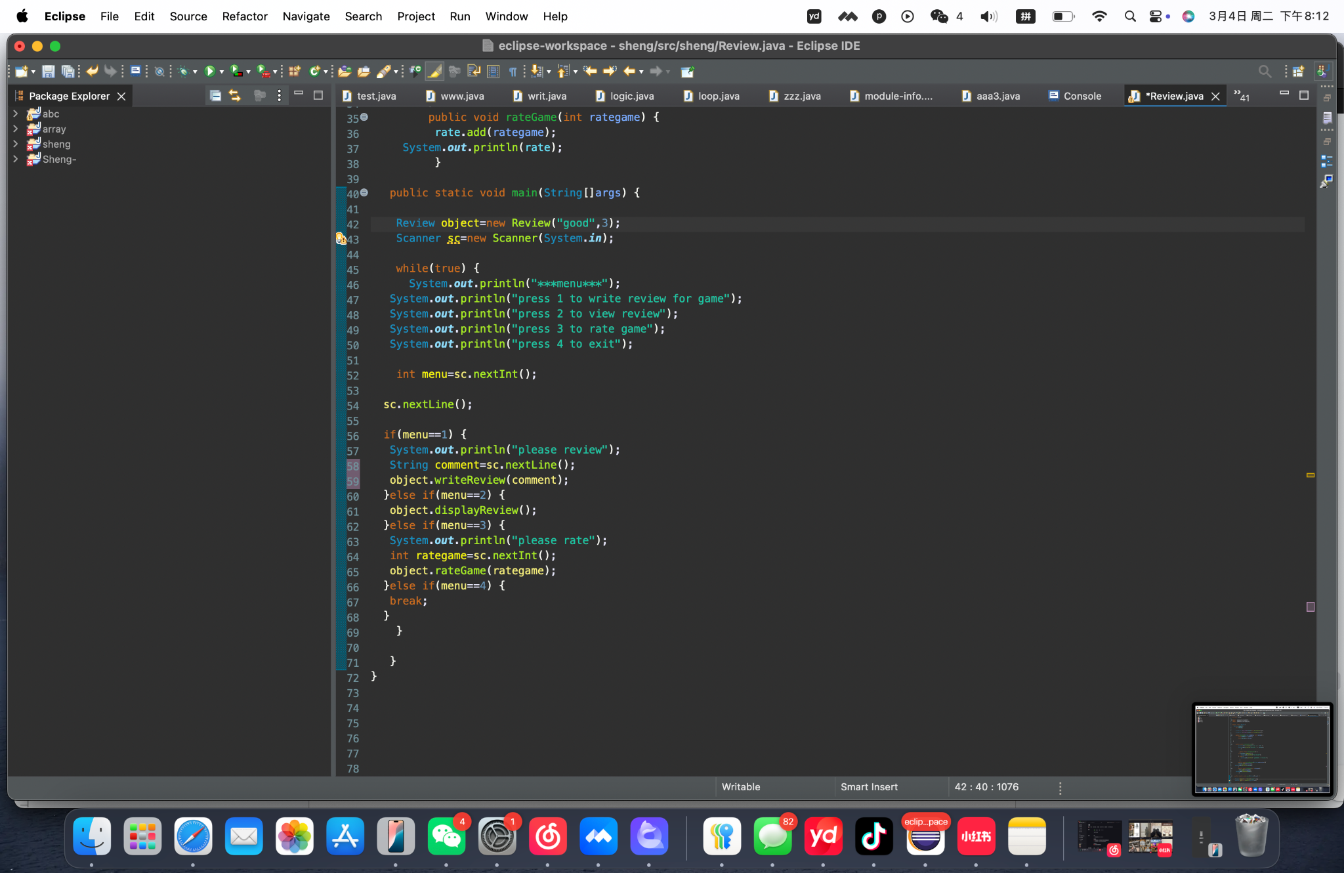

**Part 4:**

Create an Admin class that extends from the User class,to grant administrator

privileges.Administrators can add or delete games, view all users, and delete inappropriate comments.

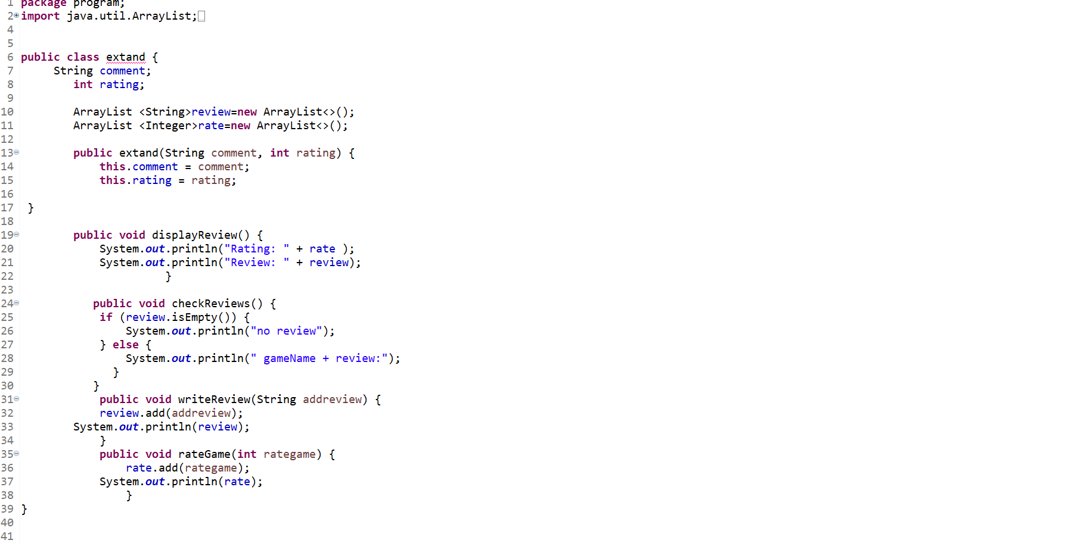

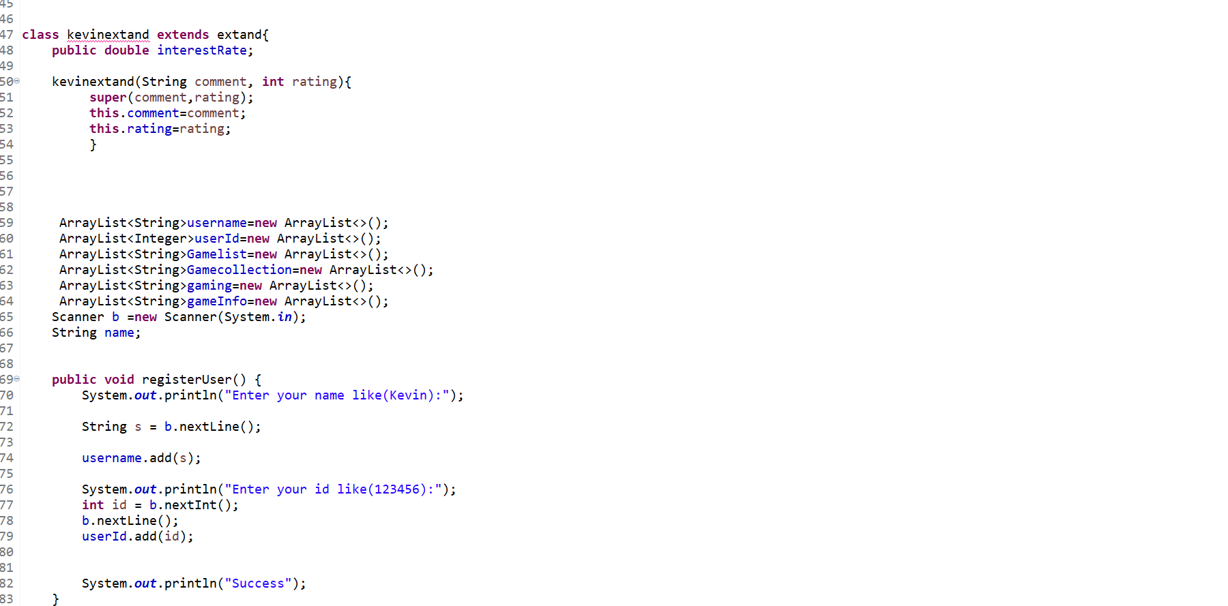

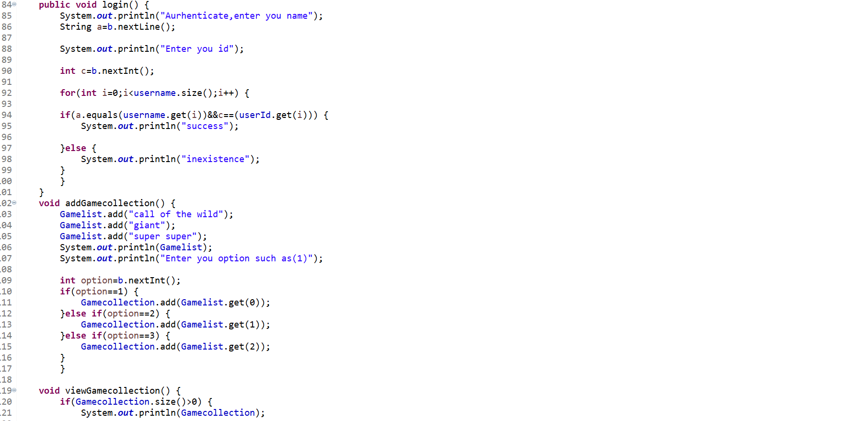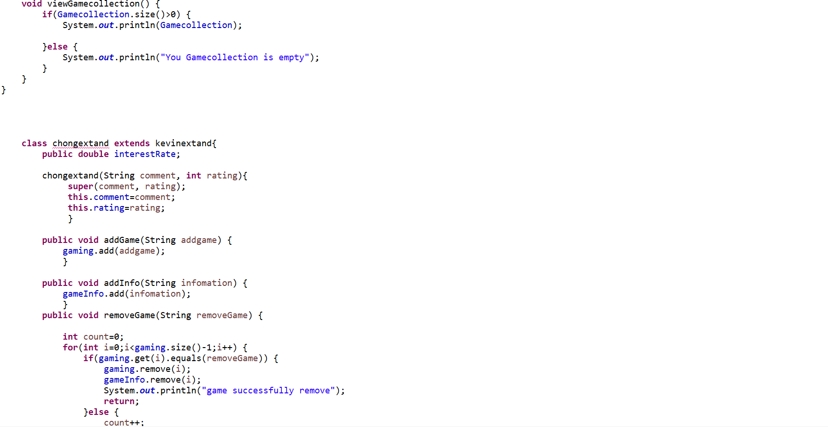

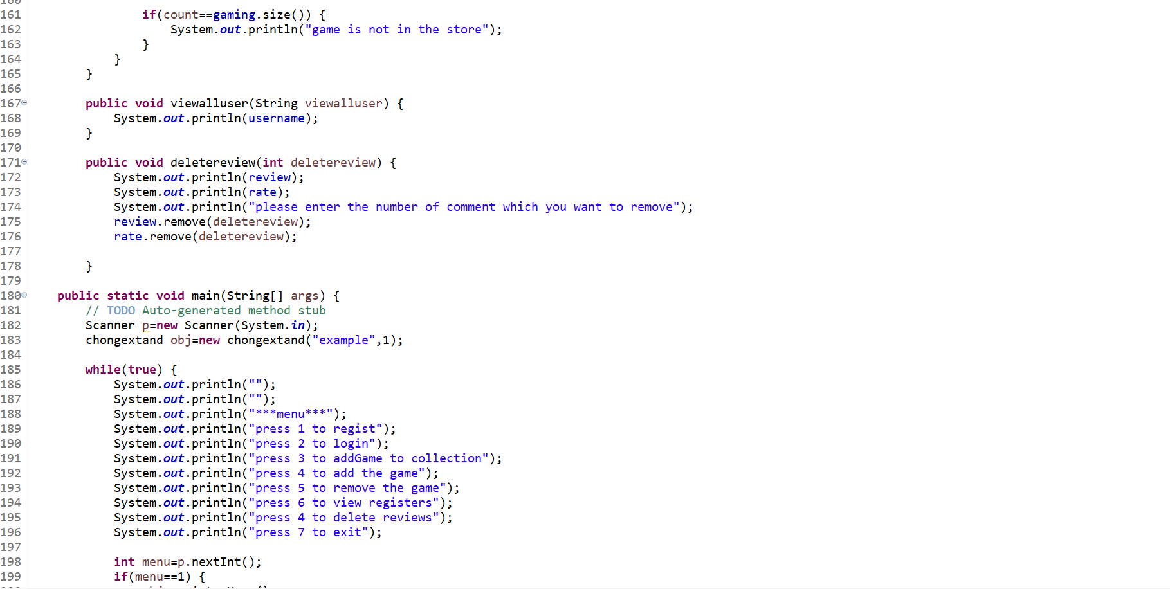

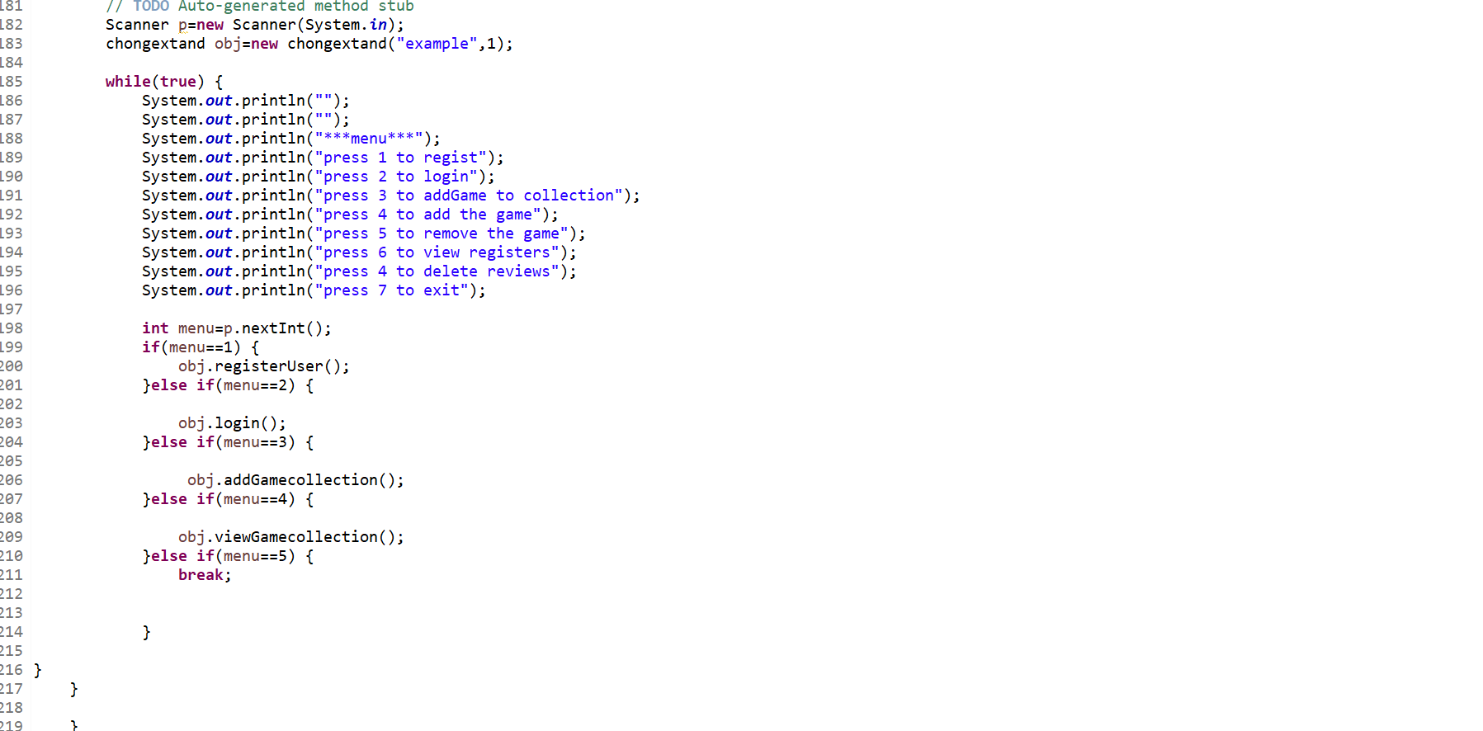

**HTML:**

**Part 1:**

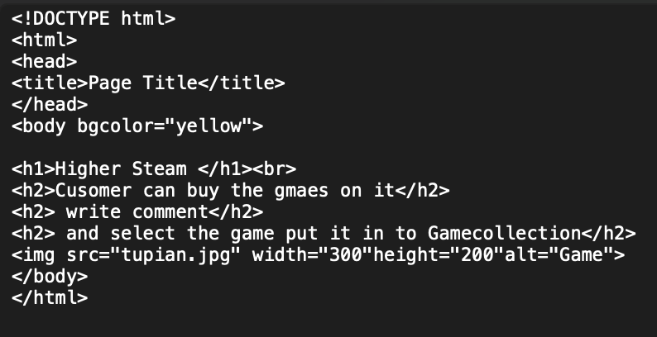

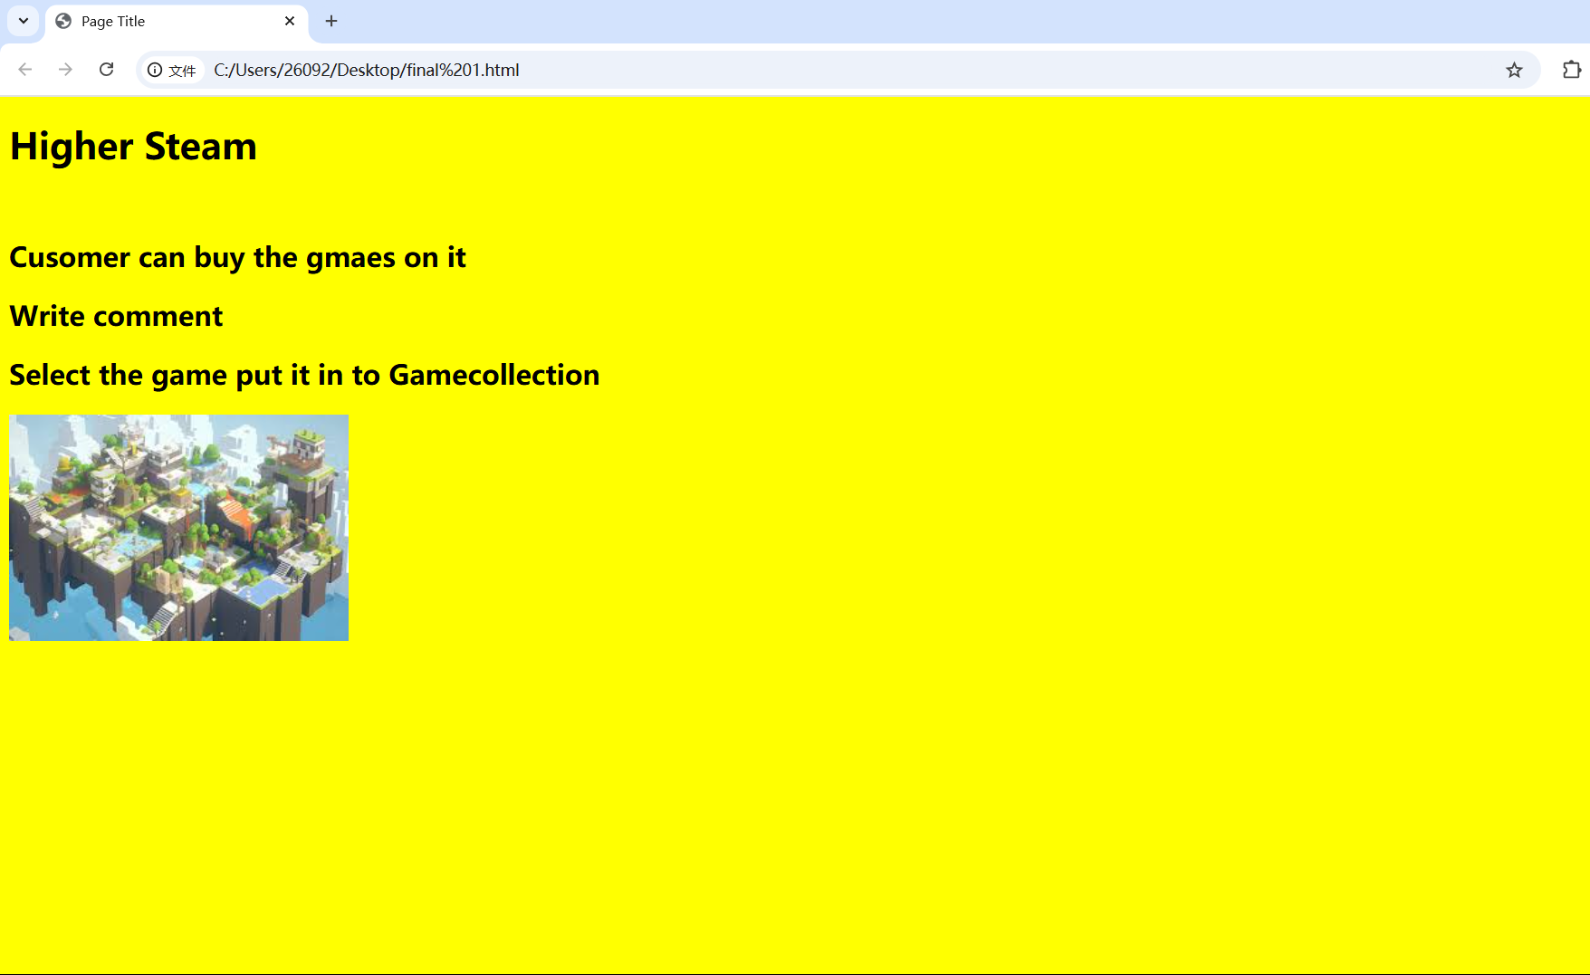**Part 2:**

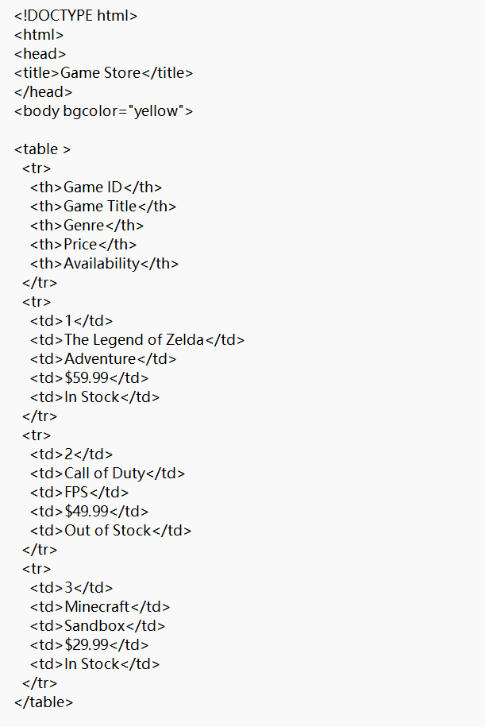

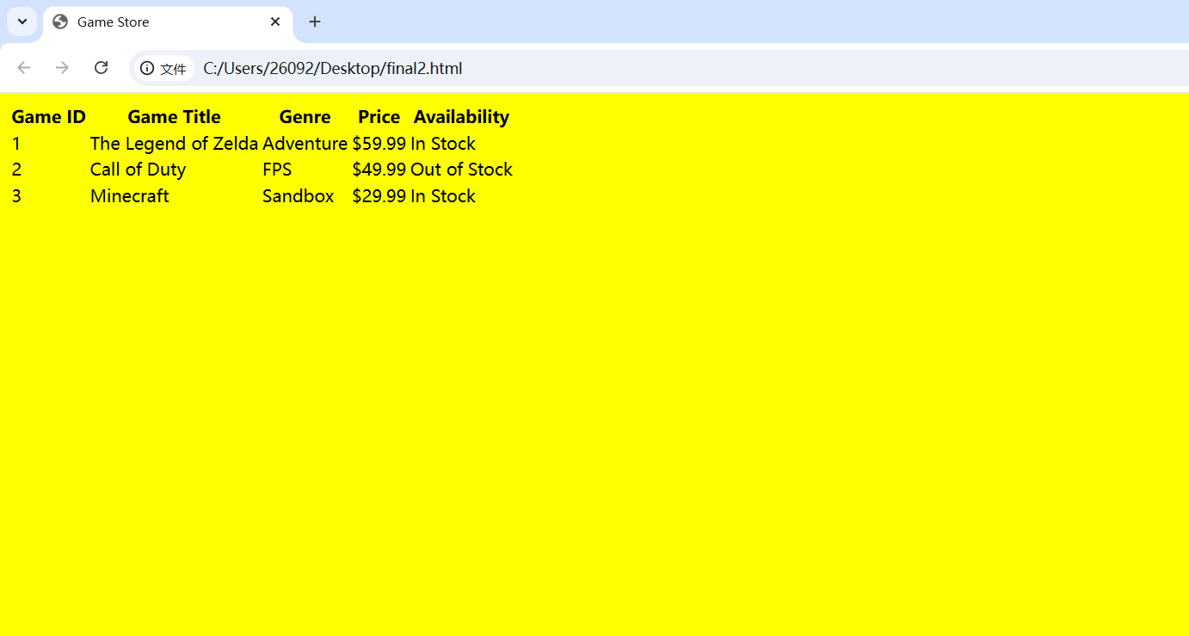

**Part 3:**

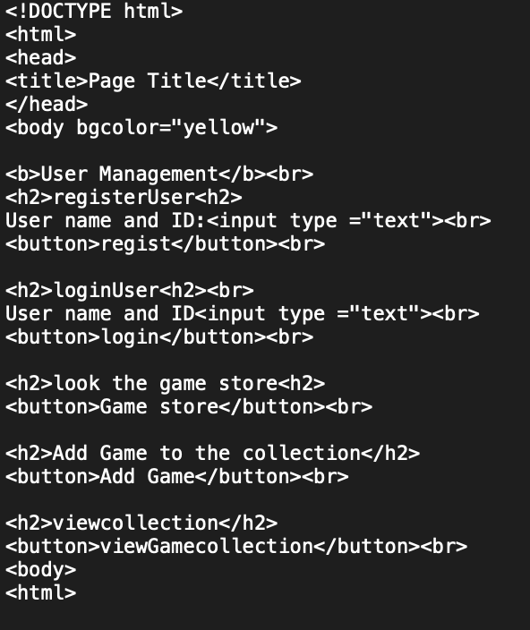

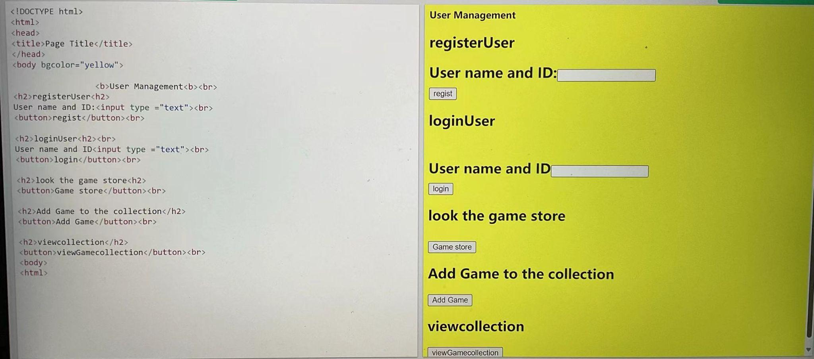

**Part 4:**

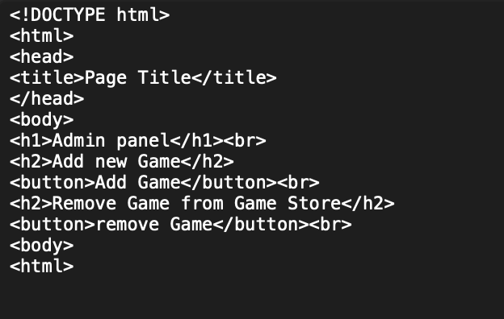

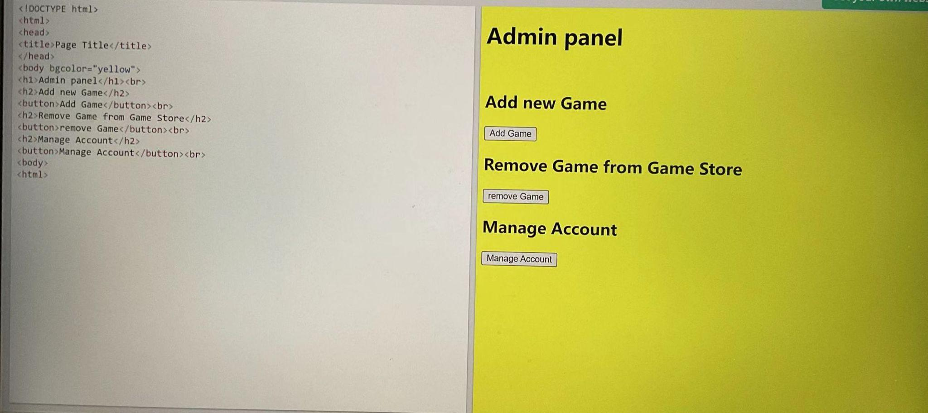

**Chapter-5**

**Reference**

**website:**

<https://www.geeksforgeeks.org/introduction-to-java/>

<https://en.wikipedia.org/wiki/Eclipse_(software)>

**Contribution:**

**Front page:** Yuriy

**Declaration:**Sheng Chen

**Table of Contents:**Chong Zhuang

**Abstract:**Yanbo Wan(Kevin)

**REPORT:**

Chapter-1:Sheng Chen

Chapter-2:Yanbo Wang

Chapter-3:Sheng Chen

Chapter-4:Sheng Chen, Chong Zhuang

Chapter-5:Sheng Chen, Chong Zhuang

**JAVA:**

Java code1:Chong Zhuang

Java code2: Yanbo Wan(Kevin)

Java code3: Sheng Chen

Java code4:Chong Zhuang, Yuriy

**HTML:**

html code1:Yanbo Wan(Kevin)

html code2: Chong Zhuang,Yanbo Wan(Kevin)

html code3: Yanbo Wan(Kevin)

html code4:Yanbo Wan(Kevin)

**PPT:**

Introduction:Yanbo Wan(Kevin)

Code display: Yanbo Wan(Kevin)

Structure demostration: Yuriy